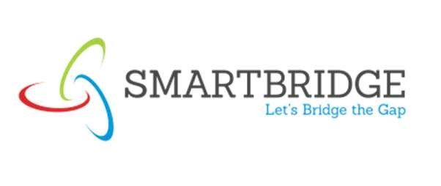


Date | 30 SEPT 2026
Team ID | SWTID-2026-9948
Project Name | EduGenie – AI Learning Assistant
Maximum Marks | 5 Marks

Problem-Solution Fit Canvas:

EduGenie is designed to provide personalized AI-powered educational assistance for students by integrating question answering, concept explanation, summarization, quiz generation, and roadmap planning into a single intelligent platform.

1. CUSTOMER SEGMENTS [CS]
• School Students
• Undergraduate Students
• Postgraduate Students
• Competitive Exam Aspirants
• Teachers and Educators
2. PROBLEMS / PAINS [PR]
• Difficulty understanding concepts
• Lack of personalized guidance
• Too much study material
• No structured learning path
• Time-consuming revision process

3. TRIGGERS TO ACT [TR]
• Upcoming examinations
• Low academic performance
• Assignment deadlines
• Need for instant explanations
• Learning new technologies
4. EMOTIONS BEFORE / AFTER [EM]
Before
• Confused
• Frustrated
• Overwhelmed
• Unmotivated
After
• Motivated
• Focused
• Confident
• Productive
5. AVAILABLE SOLUTIONS [AS]
Pros
• ChatGPT
• Google Search
• YouTube
• Online Courses
Cons
• Generic answers
• Information overload
• No personalized roadmap
• Lack of study tracking
6. CUSTOMER LIMITATIONS [CL]
• Limited study time
• Internet dependency
• Different learning styles
• Short attention span
• Difficulty finding quality resources
7. BEHAVIOR [BE]
• Frequently searches online
• Uses multiple platforms
• Watches tutorials
• Relies on AI assistants
• Studies under pressure
8. CHANNELS OF BEHAVIOR [CH]
ONLINE
• AI Platforms
• Educational Websites
• Learning Management Systems
• Online Courses
OFFLINE
• Classrooms
• Libraries
• Study Groups
9. ROOT CAUSES [RC]
• Traditional learning methods
• Lack of personalized support
• No adaptive learning mechanism
• Limited interaction with mentors
• Scattered educational resources
10. YOUR SOLUTION [SL]
• AI-powered Question Answering
• Concept Explainer
• Quiz Generator
• Content Summarizer
• Roadmap Builder
• Study Analytics
• Personalized Learning Support

